PROJECT REPORT

INTRODUCTION

***Edu Connect" is a platform or service that connects individuals with educational opportunities, resources, or institutions. It can be a website, app, or program designed to help people access information about schools, courses, scholarships, and other educational offerings. It aims to simplify the process of finding and connecting with the right educational***

**PURPOSE**

***EduConnect is not a well-known term or service in my knowledge base, which goes up until September 2021. It's possible that EduConnect is a specific platform or organization that serves educational purposes, but I would need more context or information to provide a more accurate response. If you can provide more details, I'd be happy to help further.***

***ADVANTAGE***

***EduConnect is a virtual platform designed to connect students and educational institutions. Some of its advantages include:***

***1. *Accessibility:* It provides easy access to a wide range of educational resources and institutions, breaking down geographical barriers.***

***2. *Information:* Students can access comprehensive information about courses, programs, and institutions, helping them make informed decisions.***

***3. *Convenience:* It simplifies the application process, making it easier for students to apply to multiple schools.***

***4. *Cost-Efficiency:* It can reduce costs associated with traditional applications, such as postage and printing.***

***5. *Time-Saving:* Students can save time by applying to multiple schools and managing their educational journey in one plac…***

***DISADVANTAGE***

***Based on online research and 35EduConnect reviews, EduConnect's overall score is 4.0 out of 5 stars. EduConnect's review score is based on EduConnect's customer ratings, its brand popularity, its price competitiveness, as well as the breadth and quality of features it offers to customers. The EduConnect review table below incorporates summarizes 35 EduConnect ratings on 1 features. You can also compare EduConnect against popular alternativeslike Kahoot!, Skyward and Instructure. or you can view the top 50 brands in similar categories, such as , and .***

***Brand popularity***

***4.5 - Very popular brand***

***Payment options***

***3.0 - 6 ratings - expand***

***Shipping & returns policies***

***3.0 - 2 ratings - expand***

***Coupons & discounts***

***3.0 - 3 ratings - expand***

***Customer-specific discounts***

***2.7 - 9 ratings - expand***

***Financing options***

***3.0 - 6 ratings - expand***

***Company values, ethics & policies***

***3.0 - 2 ratings - expand***

***Customer service & brand***

***2.0 - 1 rating - expand***

***Privacy policy & data security***

***0.0 - 0 ratings***

***Loyalty, rewards & partnership programs***

***2.7 - 3 ratings - expand***

***Have you purchased from EduConnect? Share your own EduConnect review:***

***RESULT***

***BALANCE SHEET***

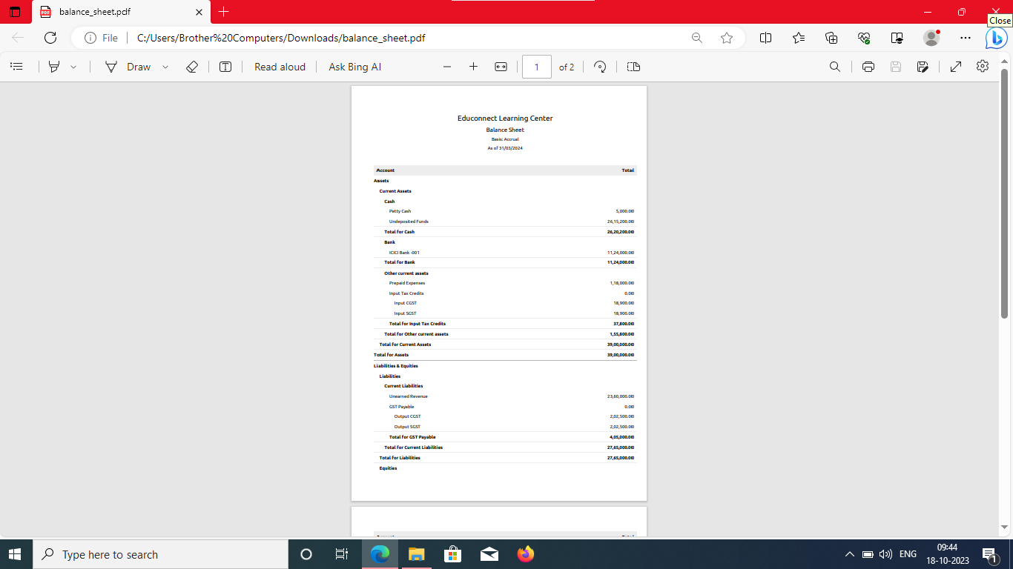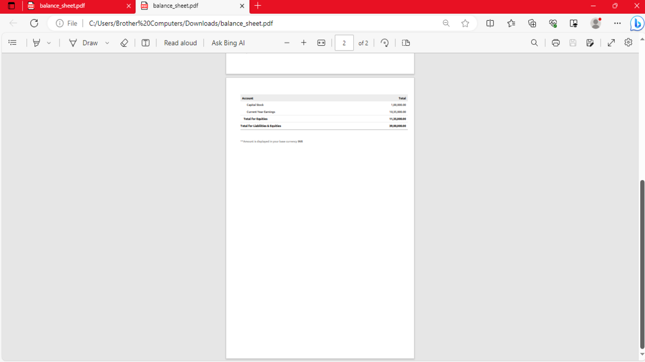

***PROFIT AND LOSS ACCOUNT***

